Looking at the Roman Baths through the eyes of a historian
Take a journey through the core skills of the History National Curriculum as you explore the Roman Baths. This trail should take you about one hour to complete. Key the number into your handset whenever you see this icon. Good luck!
‘The Terrace’ – Chronology
- 85 In what year did the Romans invade Britain? _______________________

- 85 At the end of which century were the Roman Baths re-discovered? _______

- 29 Which Roman emperor successfully invaded Britain? __________________

- 27 Approximately how many years ago did this water fall as rain? ___________

‘Meet the Romans’ – Change and Continuity
Compare the clear perspex model of the Baths in the First Century with the model of the Baths in the Fourth Century.
List all the CHANGES that you can see:

List all the CONTINUITIES (SIMILARITIES) that you can see:

Now compare the Fourth Century model with the view of the modern-day Baths through the window.
List all the CHANGES that you can see:

List all the CONTINUITIES that you can see:

Now take a seat in front of the Temple pediment. At the centre of the pediment is a Gorgon. These creatures came from Ancient Greek myth. This one, however, is different from how the Greeks normally depicted them. Compare the Gorgon on the pediment with the picture below. How does the Bath Gorgon differ from usual Gorgons? Make a list of the differences on the lines below the picture.

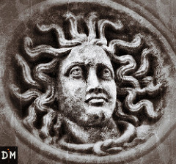
Differences: _________________________________________________________________
_________________________________________________________________
- 28 What reasons does the commentary on the handset give for the Bath Gorgon being different from traditional Greek Gorgons?
_________________________________________________________________
_________________________________________________________________

‘Life and Death in Aquae Sulis’ – Using Evidence
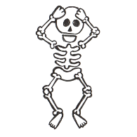
Find and stand in front of the glass case containing the full-size human skeleton.
31 What evidence do archaeologists have for each of the following?
The skeleton being wealthy ____________________________________________
The skeleton being 45 years of age ______________________________________
The skeleton being from Syria __________________________________________
What aspects of the skeleton can archaeologists not explain? __________________
‘Worshipping the Gods’ – Significance
- 15 Why was religion so important to the Romans?
_________________________________________________________________
_________________________________________________________________
Now walk around the corner and find the glass case containing the lead curses. These are regarded as being so historically significant that they have been placed on a register of the world’s most important historical documents.
- 36 Give at least 2 reasons for why the lead curses are so historically significant.
_________________________________________________________________
_________________________________________________________________
Find the lead curse which isn’t in Latin. Stephen Clews, the Manager of the Roman Baths, says that this is his favourite object in the whole museum. Why do YOU think it is so historically significant?
_________________________________________________________________
_________________________________________________________________
‘The Temple Courtyard’ – Interpretation
Over the page is an image showing what archaeologists think the Temple Courtyard would have looked like in Roman times. It is a still (picture) from the computer animation that you can see playing on the TV screen as you walk into the Temple courtyard.
Your task is to annotate (label) the still. You need to point out where the archaeologists have definite evidence for the Temple courtyard being like this and where the archaeologists are guessing.
To do this task you need to look carefully around you. It would also be worth reading the information panels and listening to what the handset has to say about the Temple courtyard.

Evidence – 5 of these 13 steps are still visible

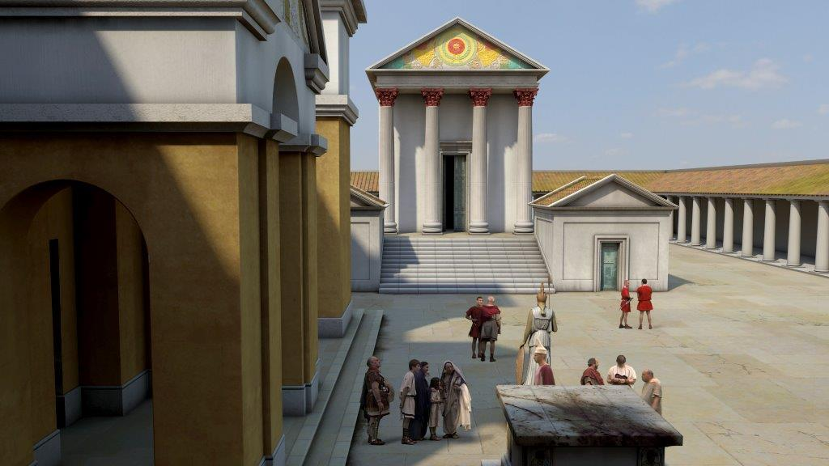

Audio commentary no. 90 | Audio commentary no. 167 | Audio commentary no. 41
Commentator = Stephen Clews, Roman Baths Manager | Commentator = Michael Rosen, children’s author | Commentator = Bill Bryson, American travel writer
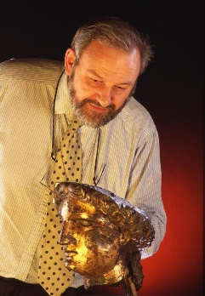 | 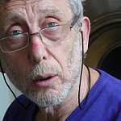 | 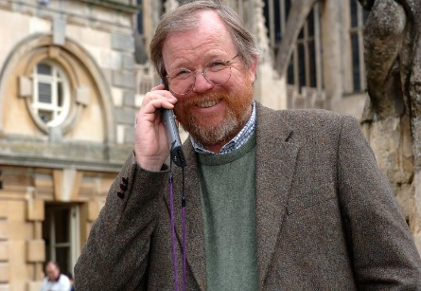
Audience = adults who want to learn as much as possible | Audience = children | Audience = adults who want to be entertained and to experience a different viewpoint
Stephen Clews appeals to his audience by . . . | Michael Rosen appeals to his audience by . . . | Bill Bryson appeals to his audience by . . .
Now go and stand beside the gilded bronze head of Sulis Minerva at the top of the Temple courtyard. Listen to all 3 audio commentaries to complete the table below.

‘The Baths’ – Written Communication
You are now back outside ready to complete the final, most exciting part of the trail. Your task is to complete a word bank ready for when you return to school to help you compose a piece of creative writing about the Baths. Complete the table below. The audio commentaries will help you and the first one has been completed for you. Start by turning left into the East Baths and continue in a clockwise direction.
Room Name | Latin Meaning | Describing Words
Balneum | Deep immersion pool | whole body healing comforting
Caldarium (43)
Tepidarium (54)
Apodyterium
Natatio (11)
Great Bath (52) | N/A
Frigidarium (96)

Finally, have a taste of the hot spring water using the paper cups provided. What describing words would you use for this?

