Visiting The Roman Baths
Clore Learning Centre

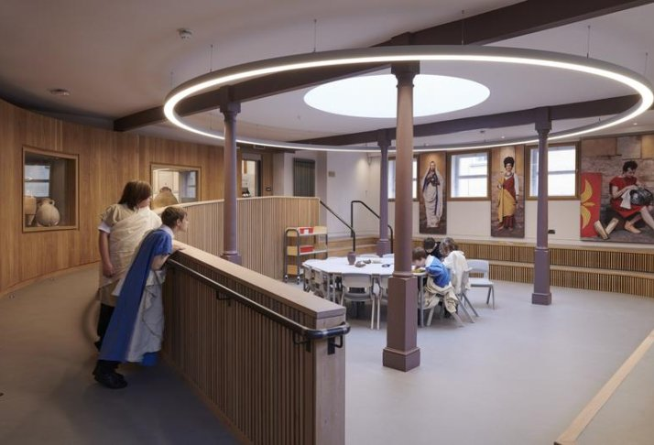

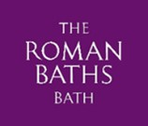
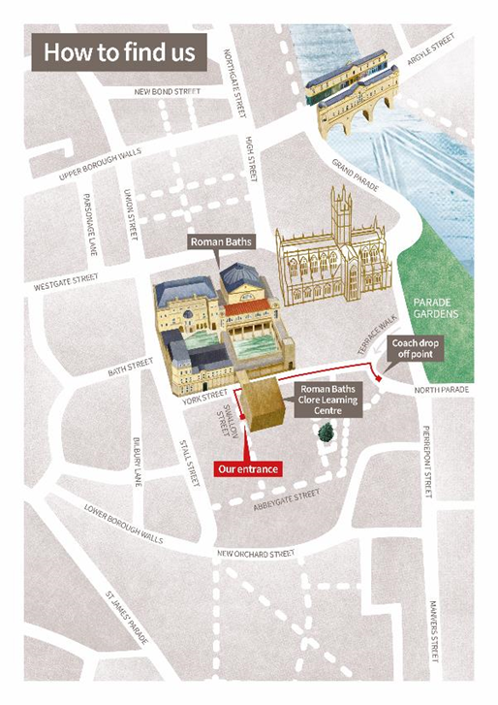
How to Find Us:
Roman Baths Clore Learning Centre
Swallow Street,
Bath,
BA1 1 RB
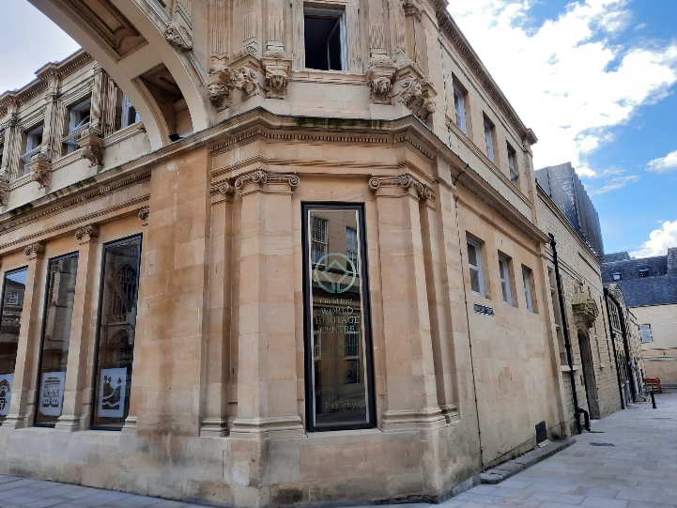

The Clore Learning Centre entrance is situated on Swallow Street, which is a small side street turning off from York Street.
When you arrive at the Learning Centre, you will see two big green doors with a doorbell on the right.
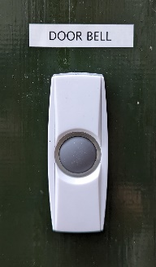
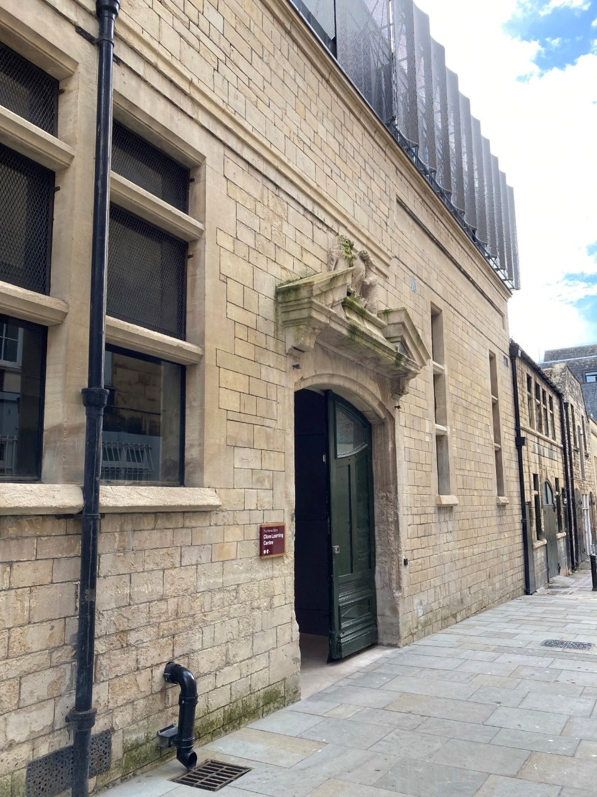

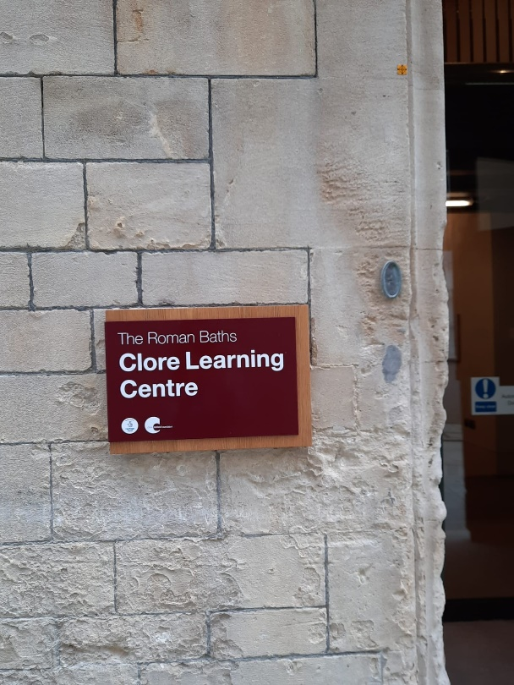

An adult will ring the doorbell to let the learning team know you have arrived.
A friendly member of staff will open the automatic door and greet you.

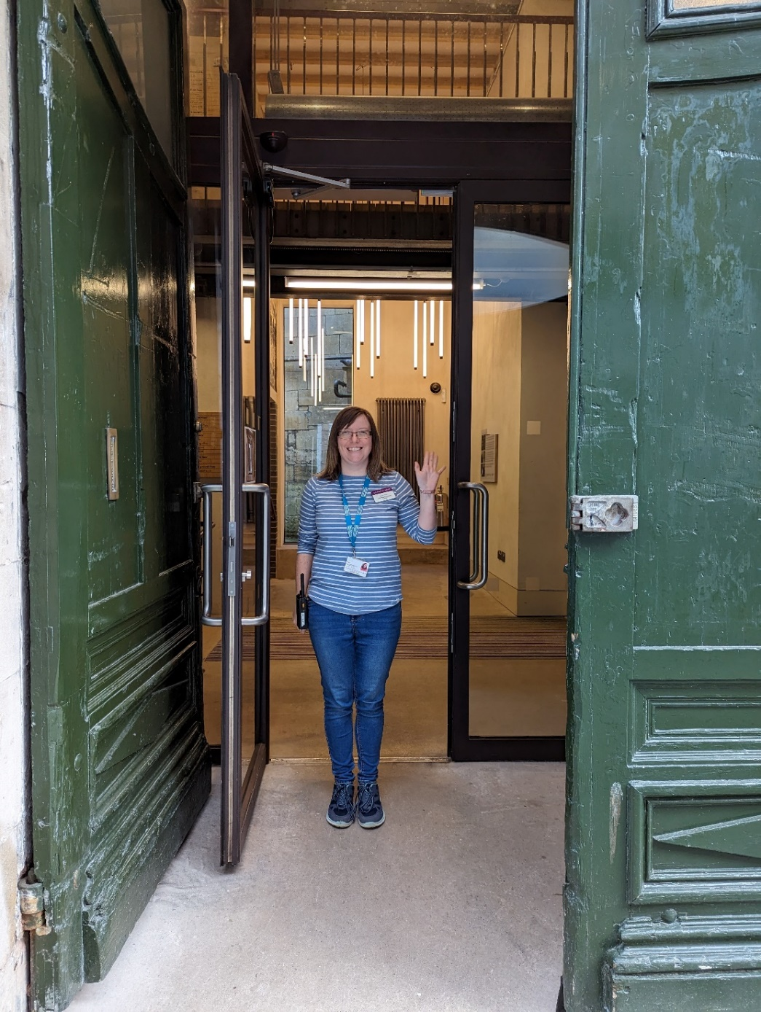

Our door will open out towards you, so please step away and make space.
The Learning Centre has two upper levels and a lower level. Our staff will show you where you need to go.
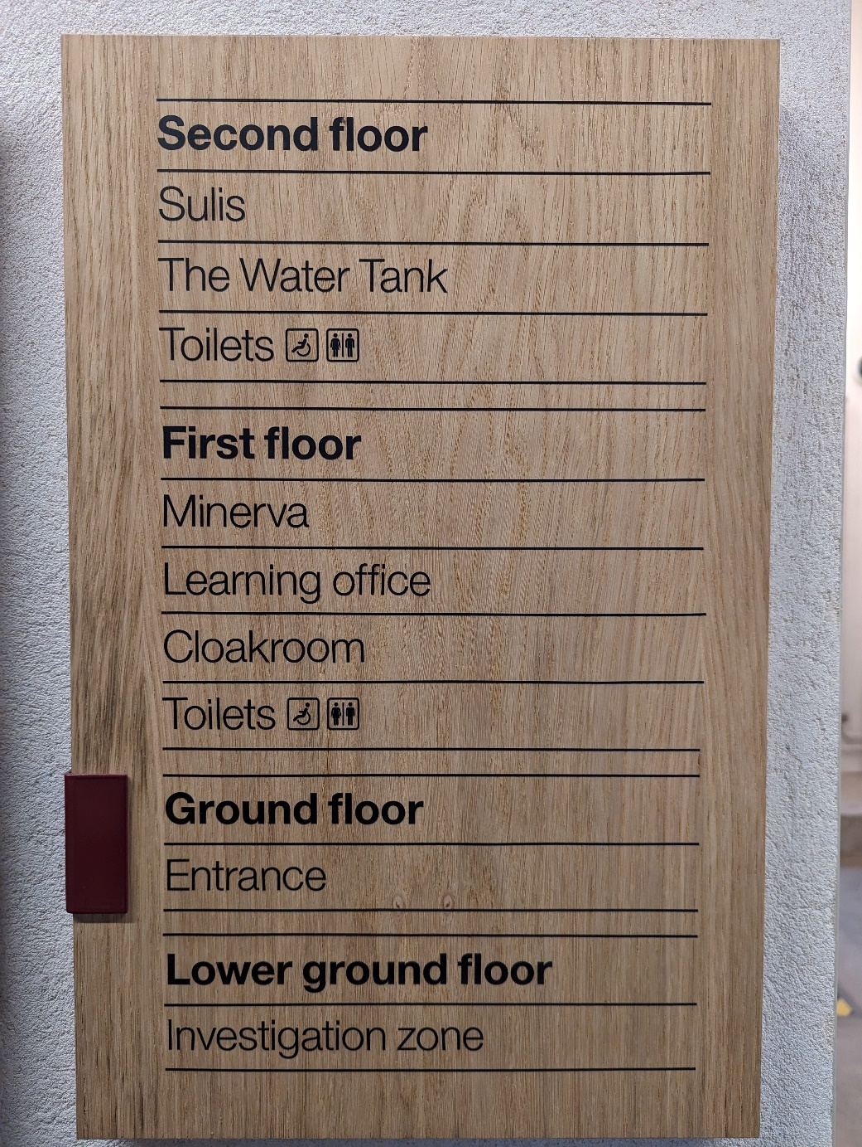

You may see and hear another school or members of the team in the building.
If there is an emergency, you will need to follow these signs.

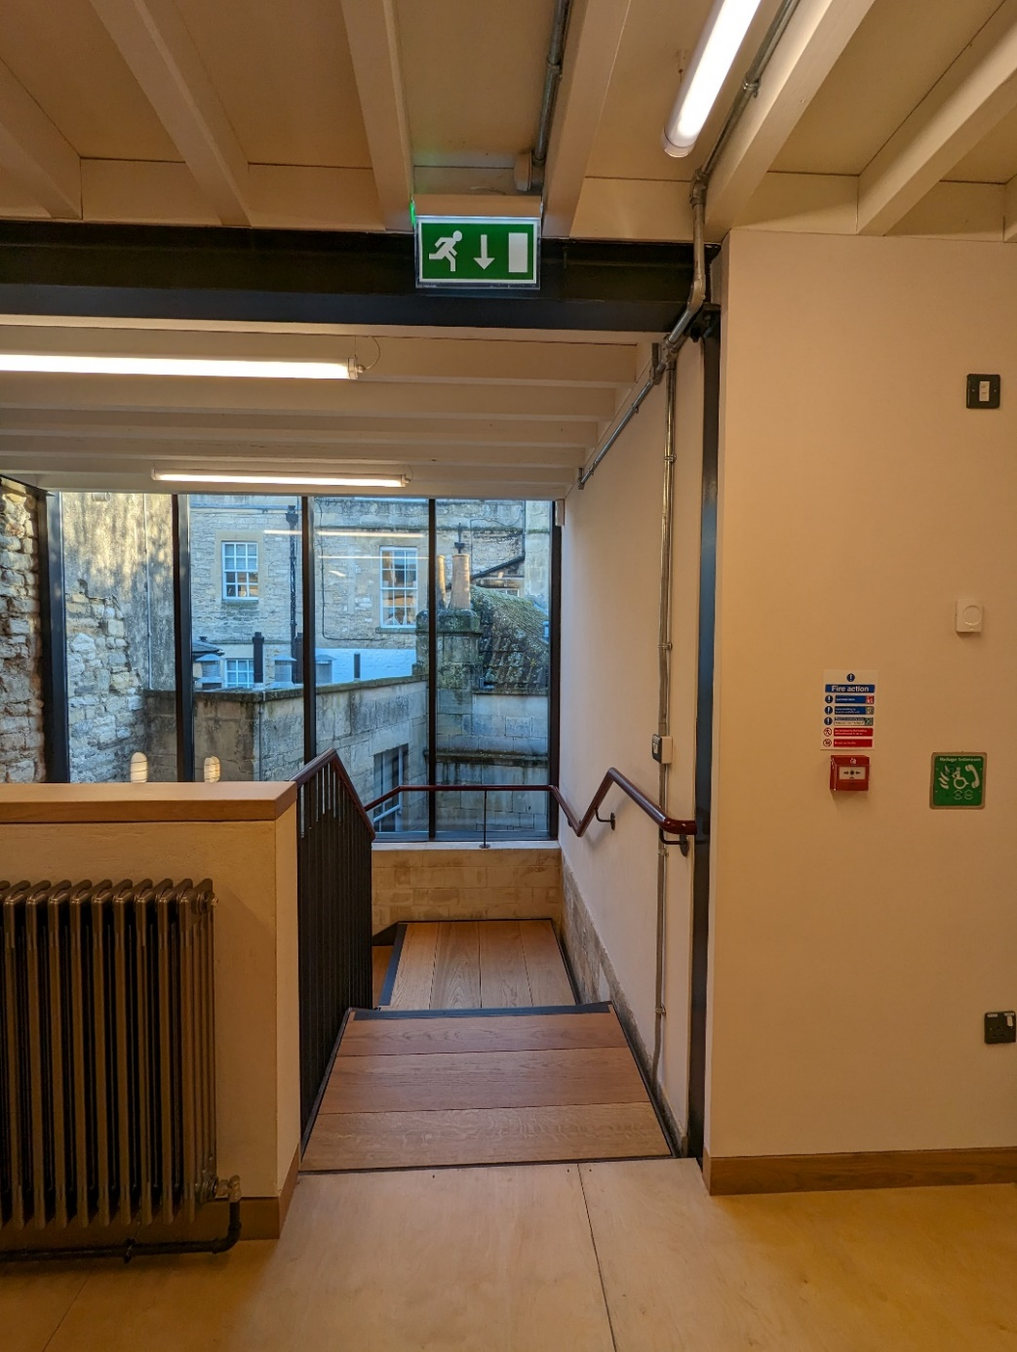

Please stay with an adult or a member of staff and walk calmly.
Inside of the entrance of the Learning Centre you will be on the First Floor.

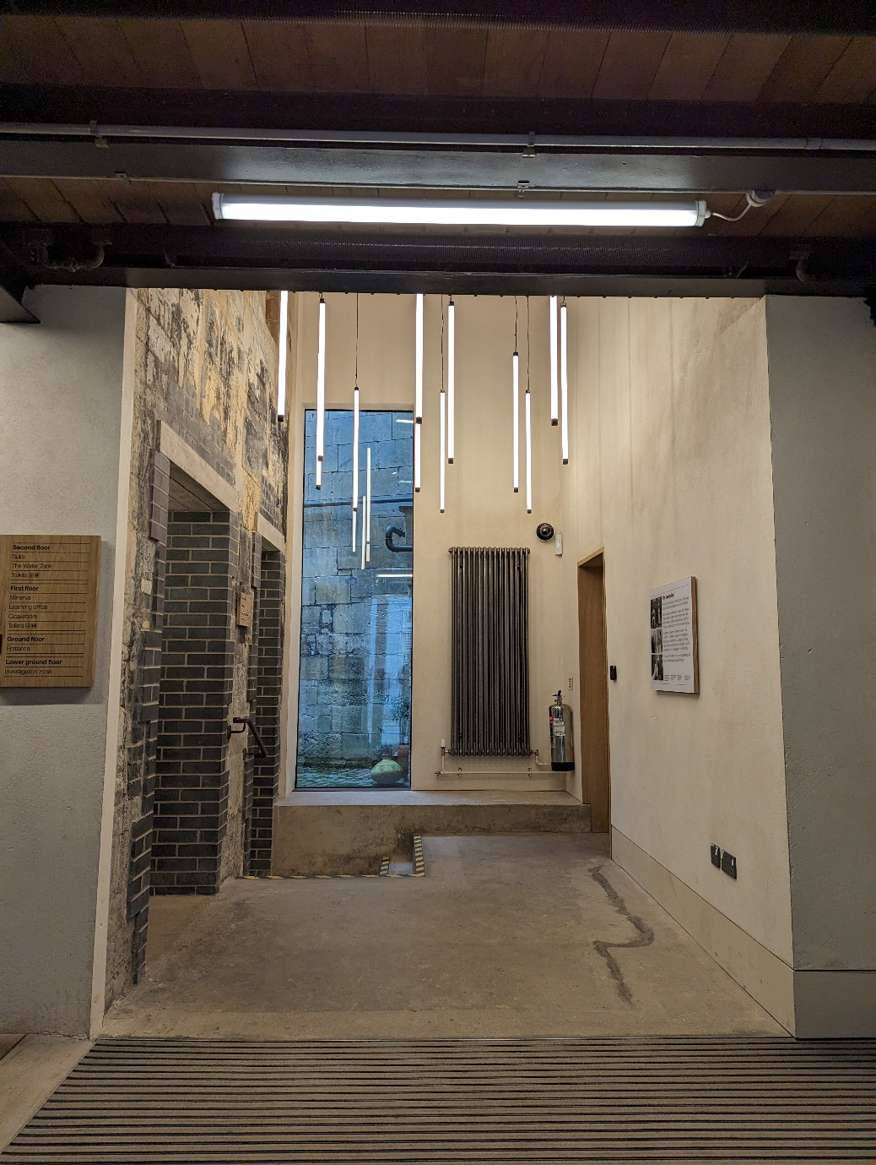

You will be guided to where you will be storing your bags and coats.
These are stairs to our Upper Floors and Lower Ground Floor.

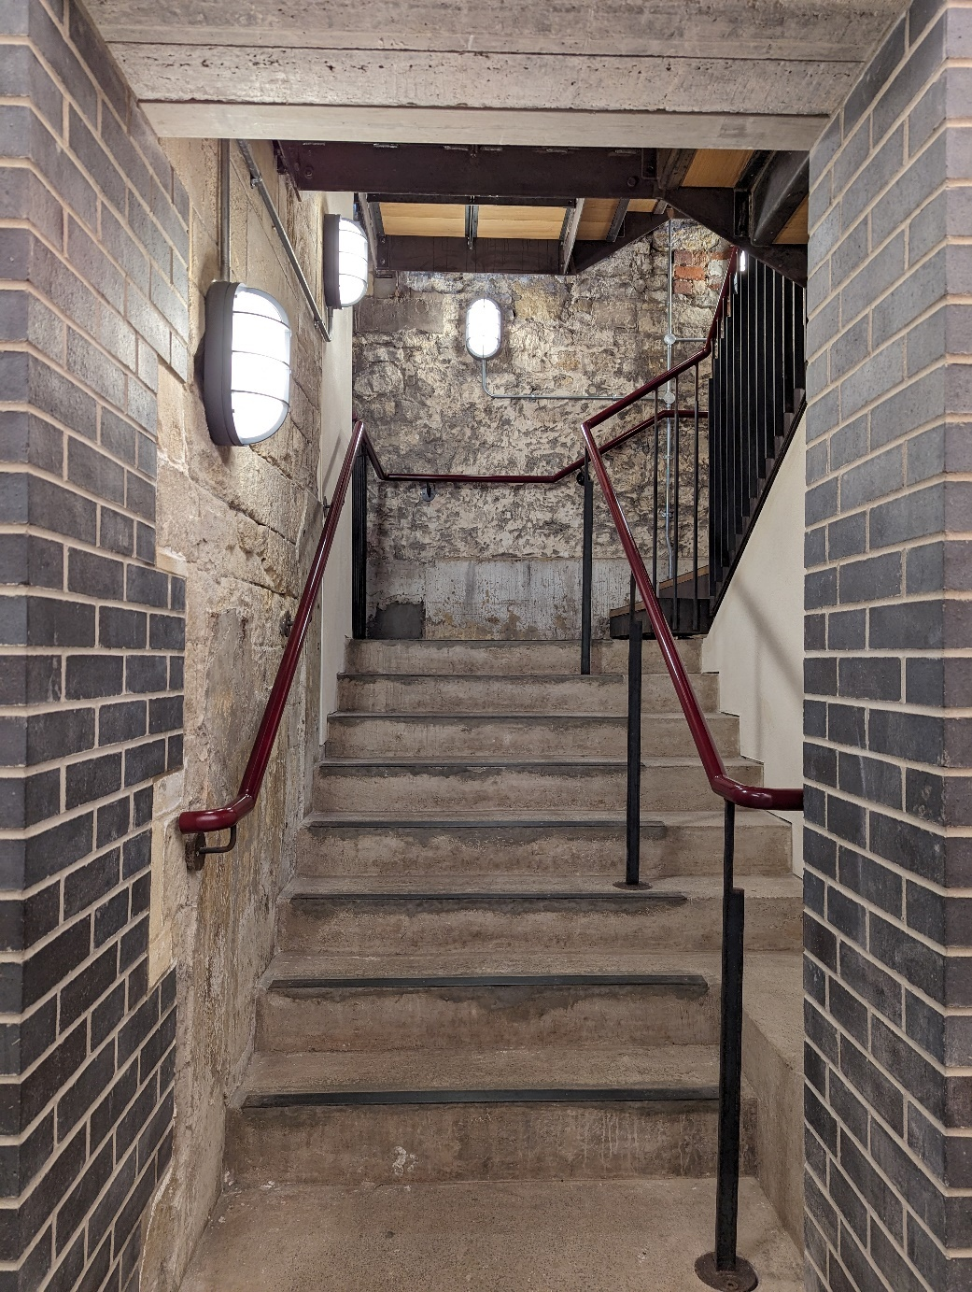

There are handrails to help guide you on the stairs.

If you want or need to, you can use the Lift. The lift is located to the left.

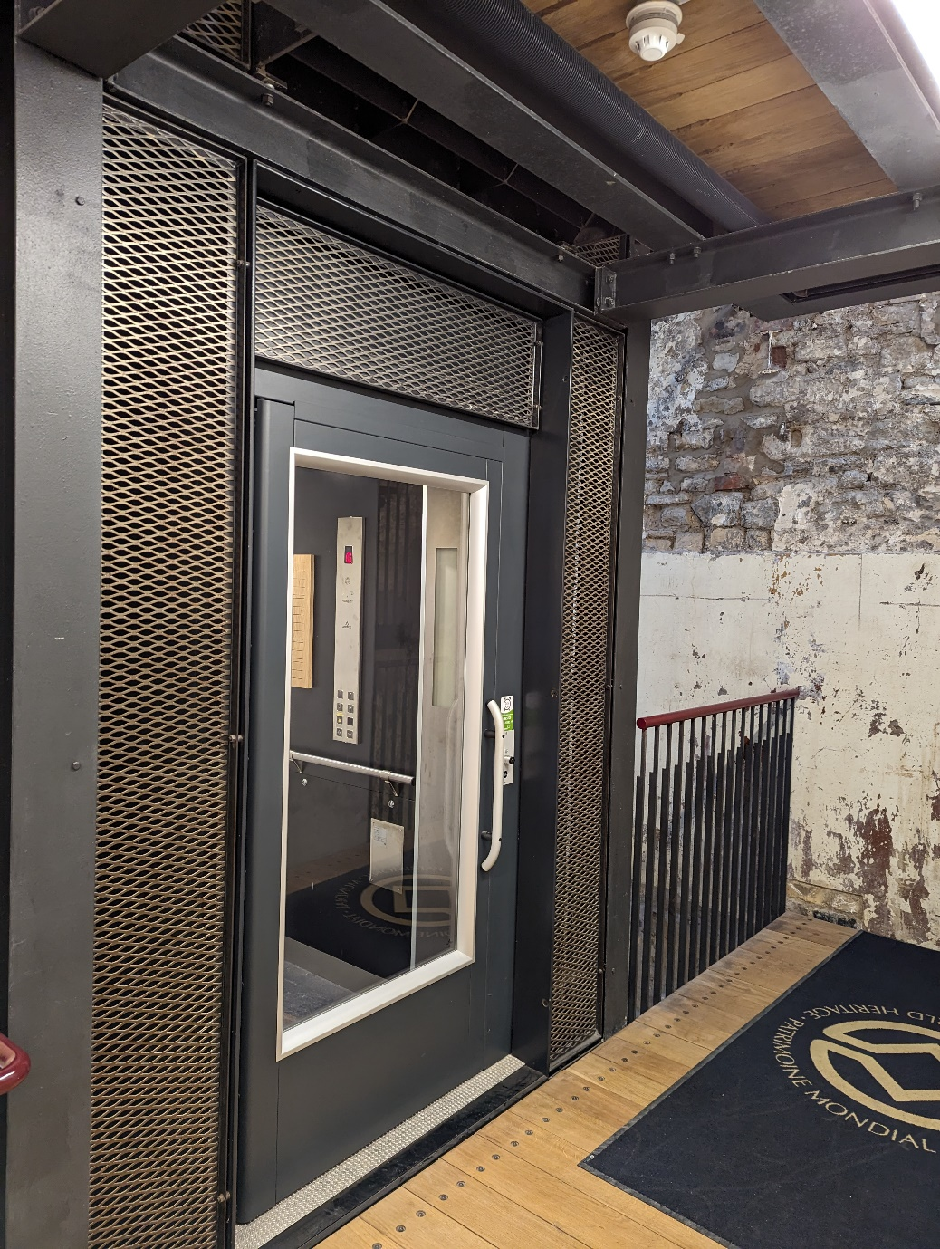

Please ask a member of staff for assistance.
This is our Cloakroom. There are wooden cupboards and metal cages.

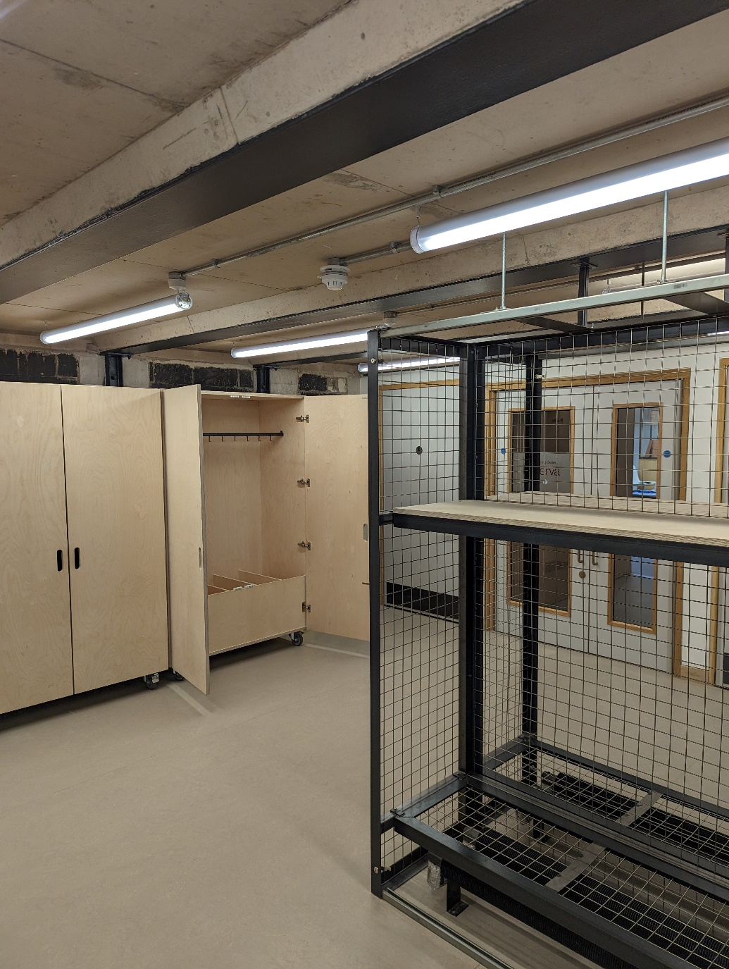

These will keep your belonging safe.
There are toilets on the First and Second floor. Each toilet has its own sink and hand dryer.
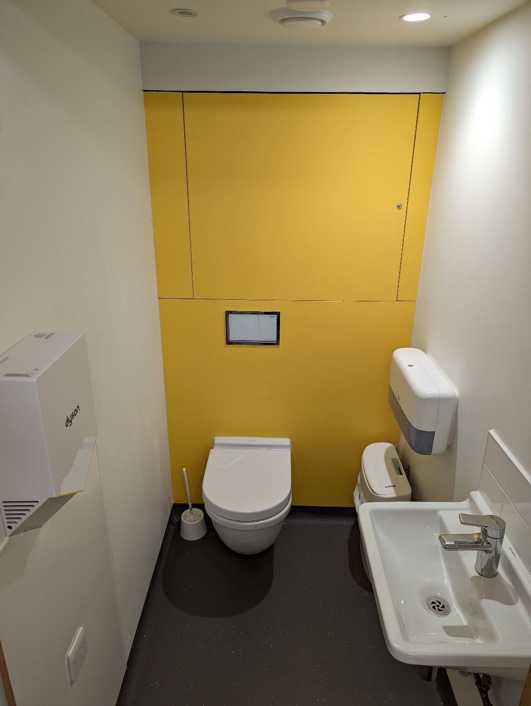

If you want or need the hand dryer to be turned off, please ask a member of staff.
The accessible toilets are located on the First and Second floors.

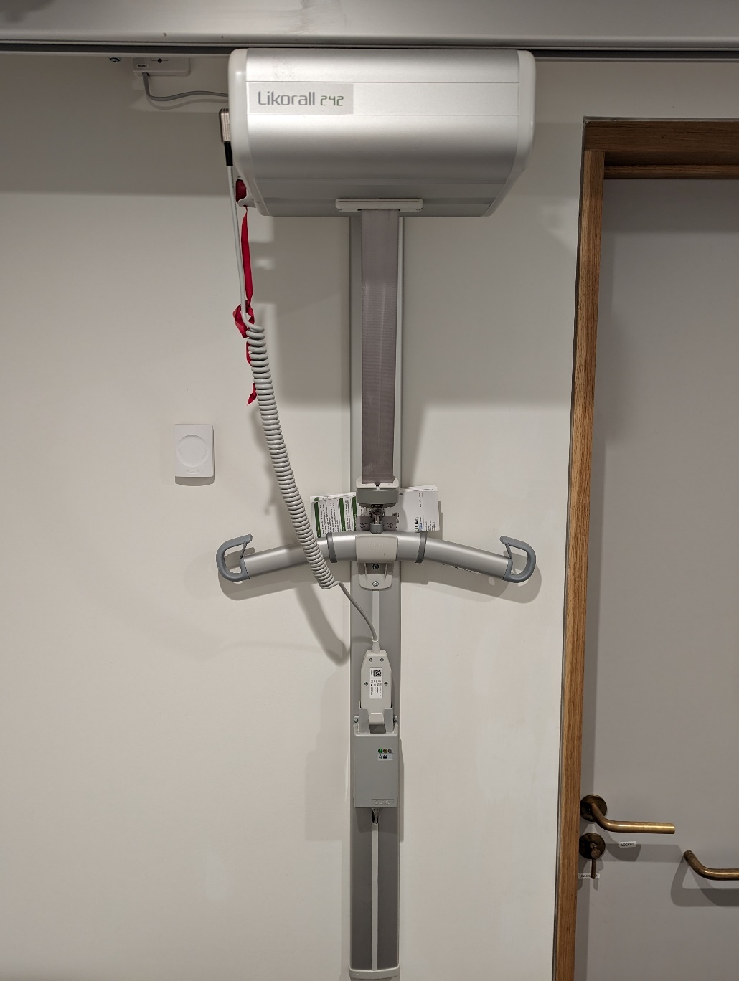

A hoist is located in the Second floor accessible toilet.
This is Sulis. This is used as a teaching or lunch space. There is a ramp to the right
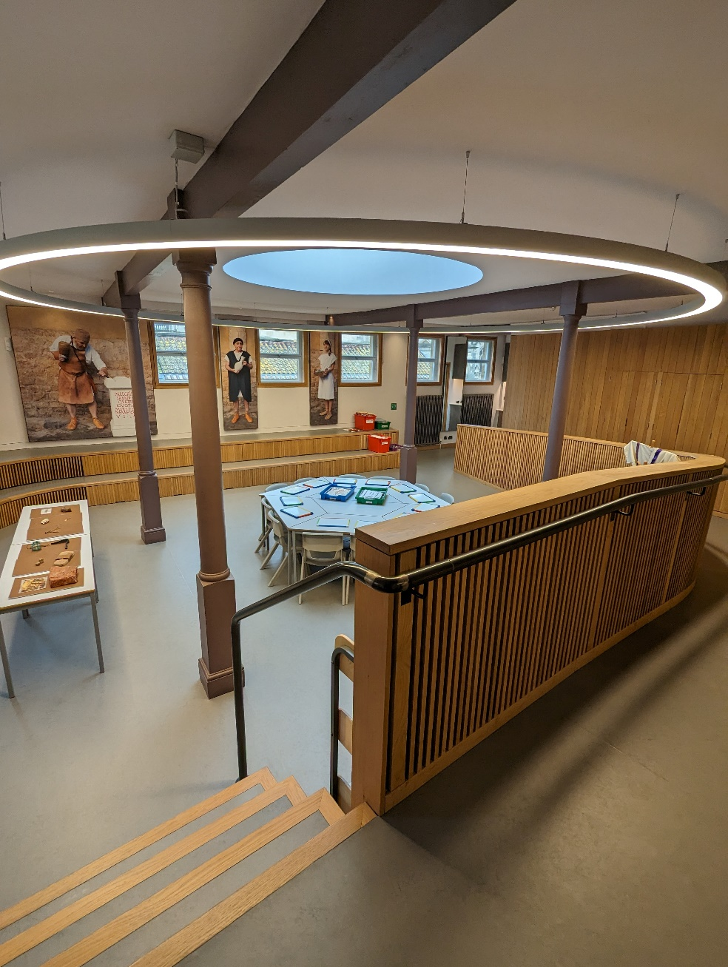

There is a sink in this room with access to drinking water. The tables and chairs may be set up differently.
This is Water Tank. This is used as a lunch and teaching space.
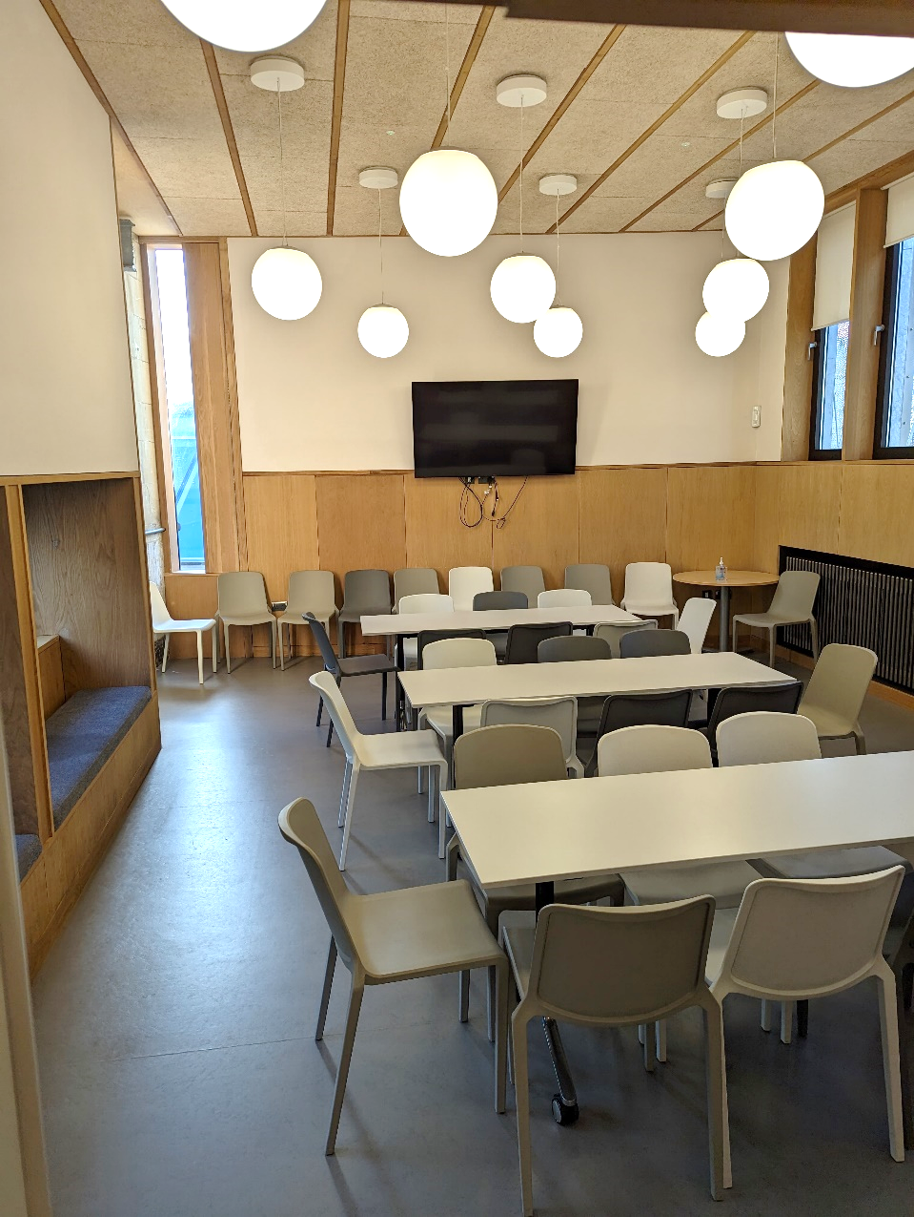

There is a sink in this room with access to drinking water. The tables and chairs may be set up differently.
This is Minerva room. This is used as a lunch and teaching space.
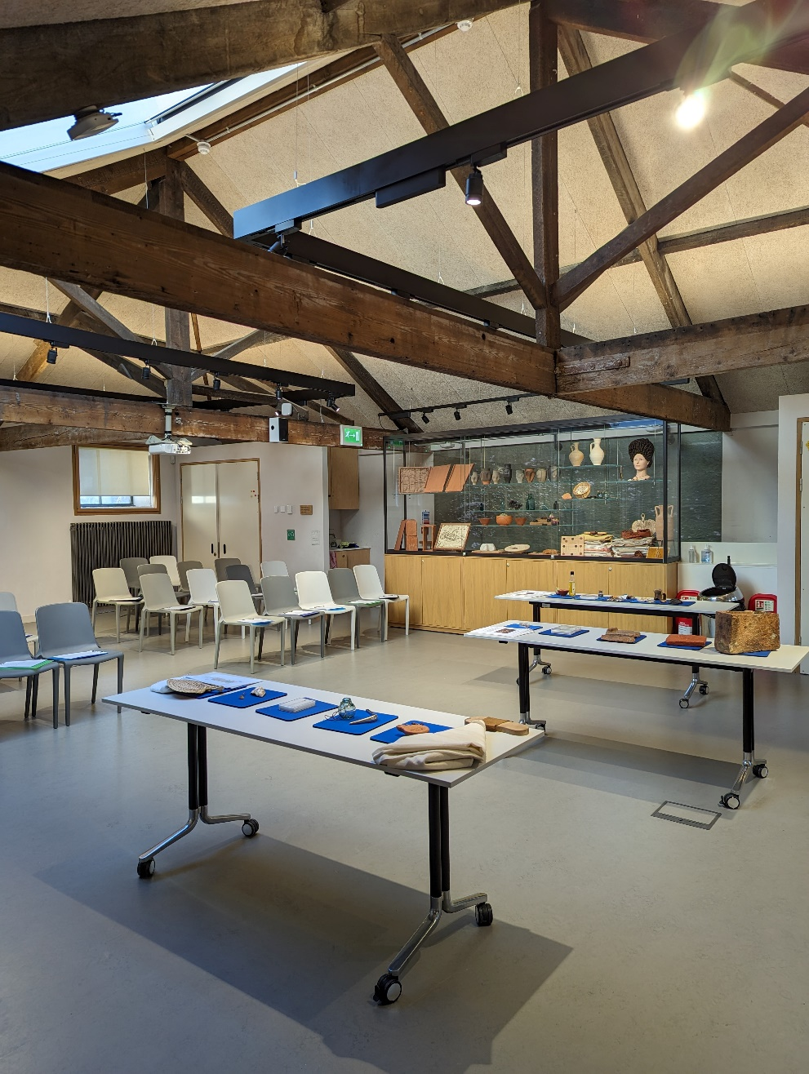

There is a sink in this room with access to drinking water. The tables and chairs may be set up differently.
These are the stairs to the lower ground floor.
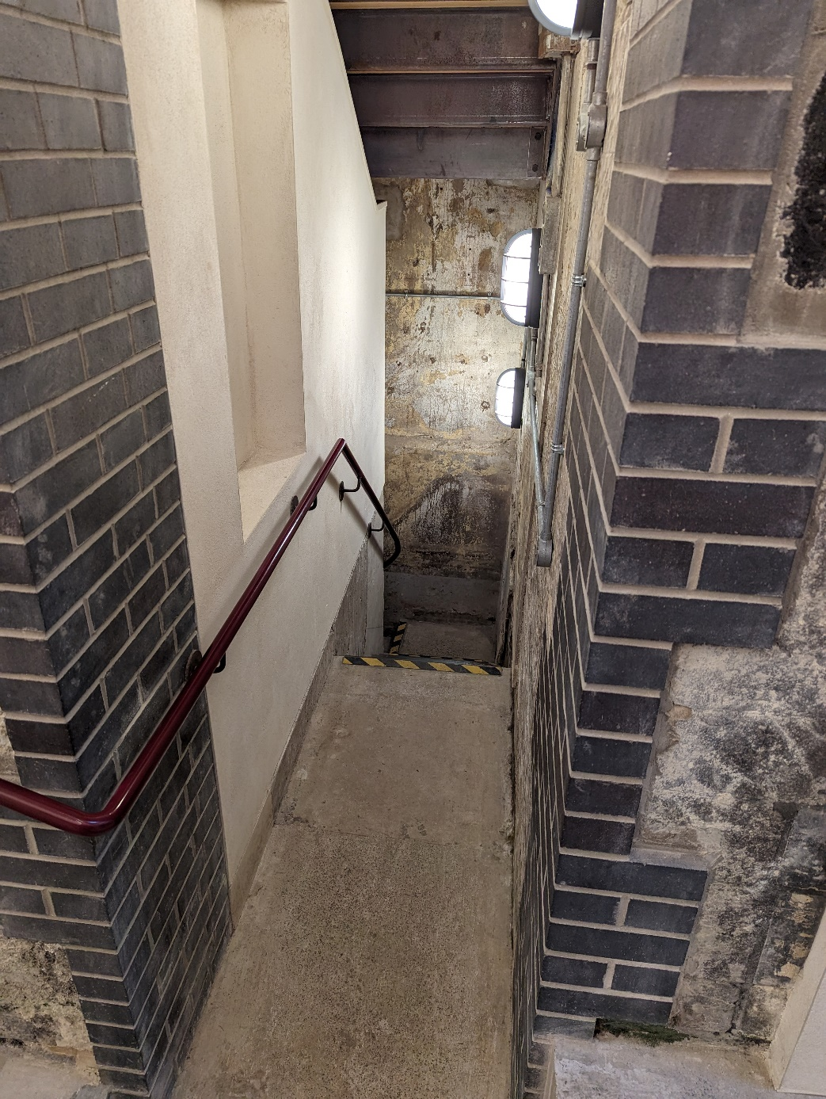

There are handrails to help guide you on the stairs.

This is the Investigation Zone. It is under the street level.
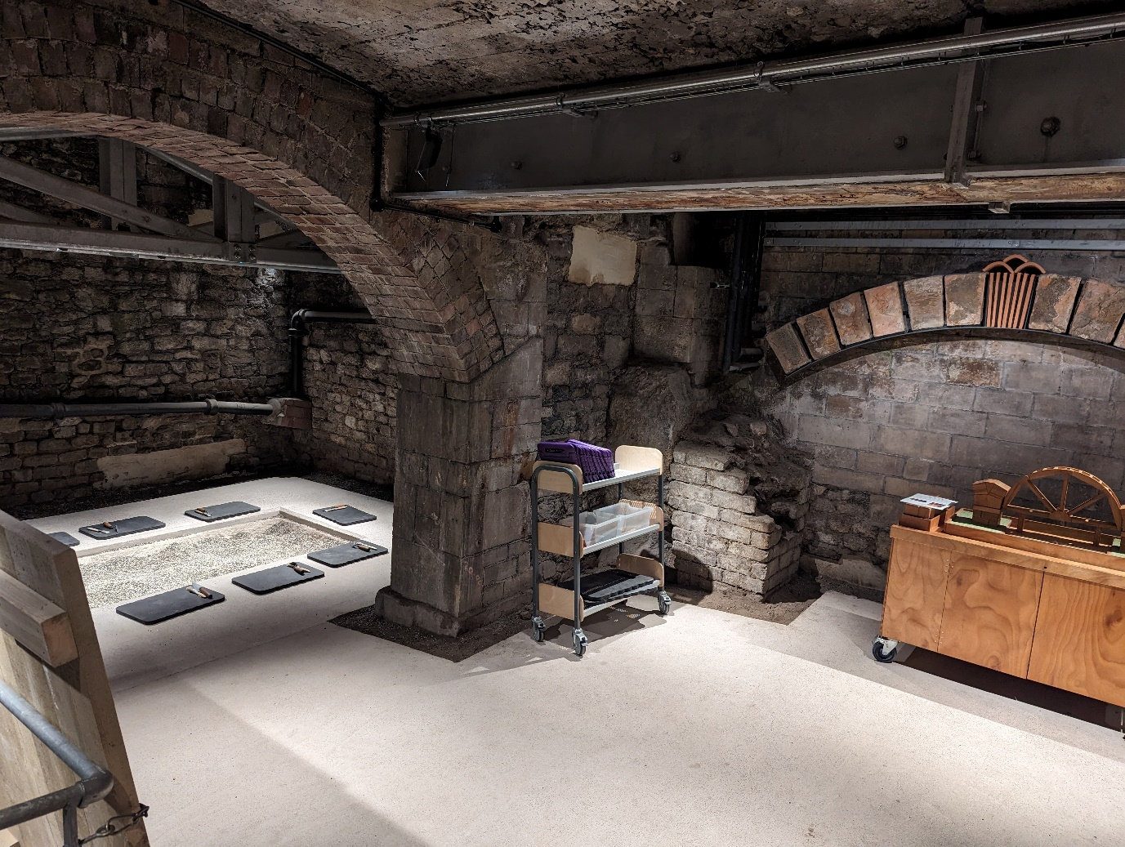

The lighting level is low to help protect the Roman ruins.

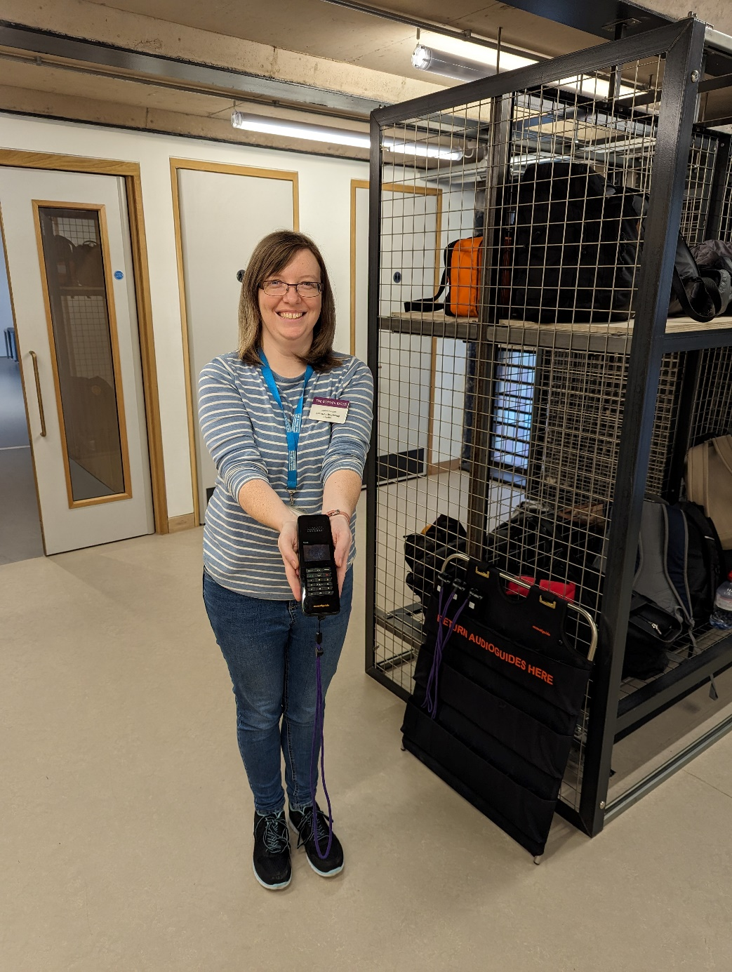
When it is time for you to visit The Roman Baths Museum your Adults may ask you to take your belonging or store them in the Cloakroom.

You may be given an Audio Guide. We have BSL guides and text upon request.
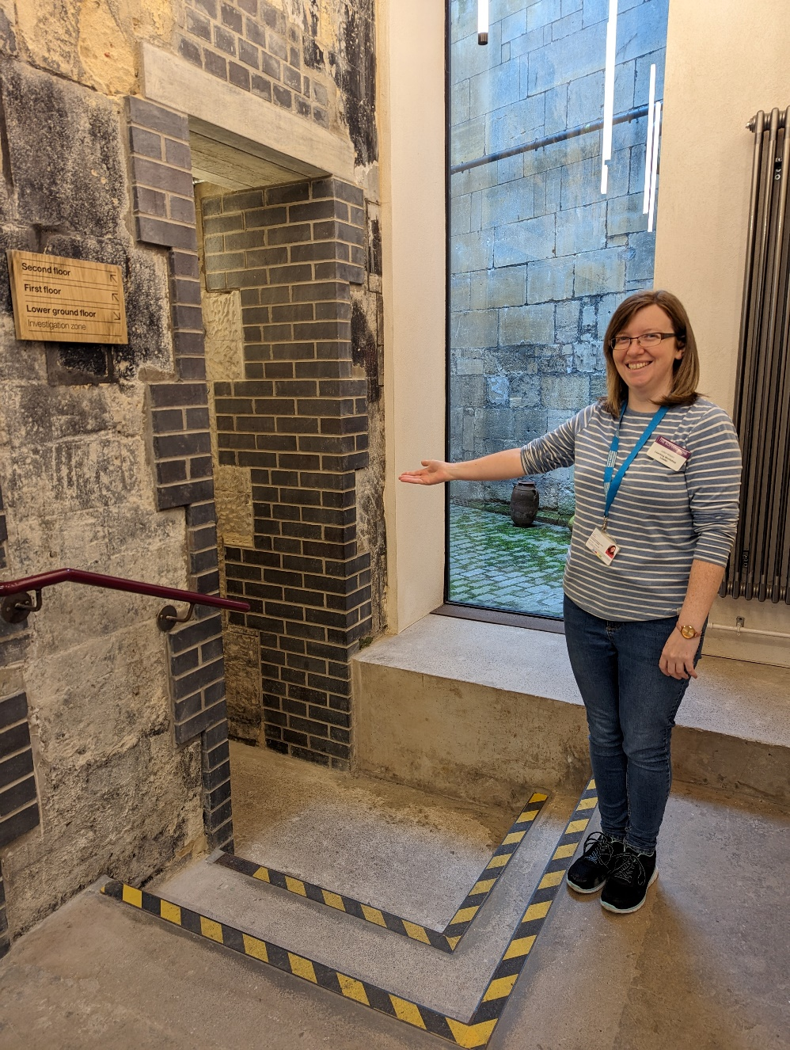
A member of staff will guide you to the beginning of the Museum.

We will walk through part of the museum. You will be able to return to these as you make your way through the one way system.
This is the tunnel entry to the Roman Baths.
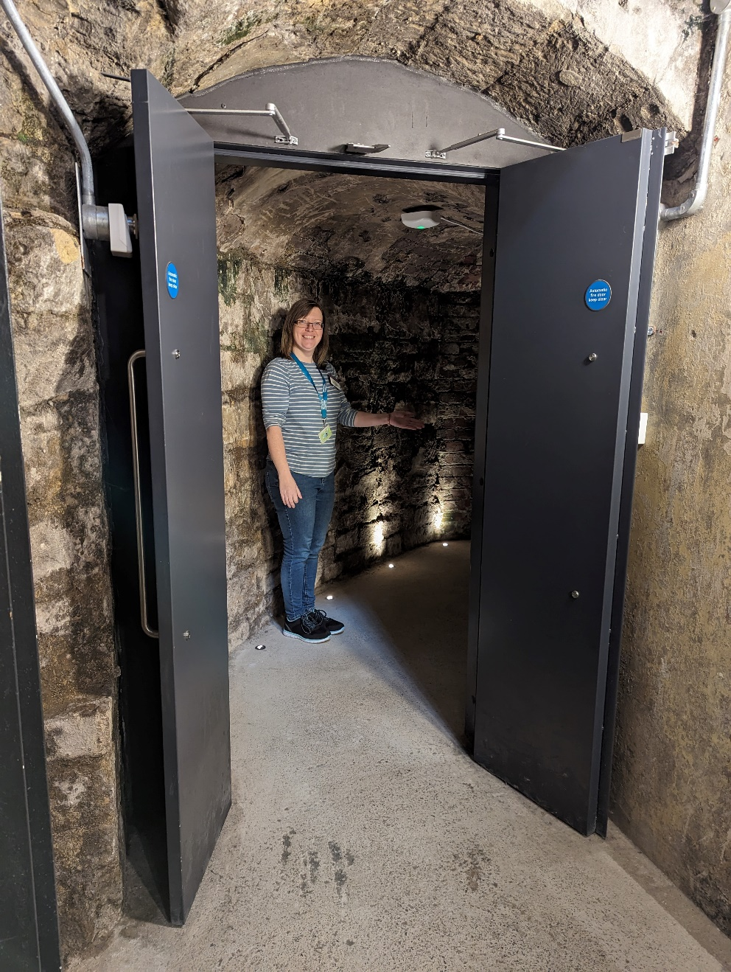

If you do not wish to go through the tunnel you can enter the museum through the main entrance in the Abbey Churchyard.
This is the Gymnasium. We will walk through here to get back to the beginning of the museum.
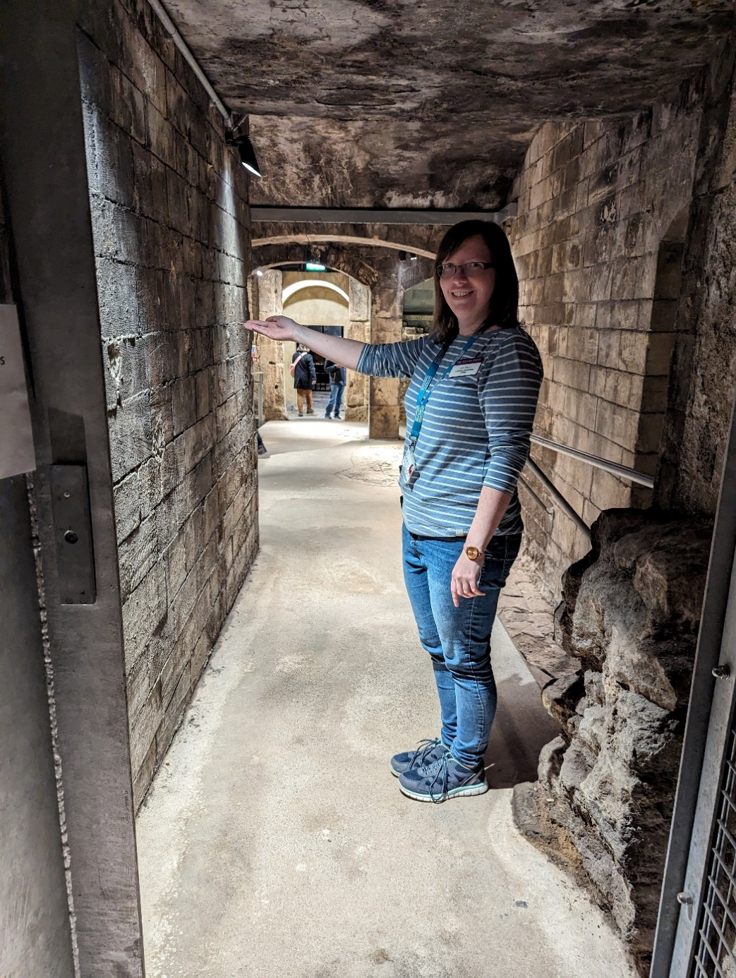

You may see or hear visitors here enjoying their visit of the museum.

This is the Great Bath. The floor is uneven so please mind your step.

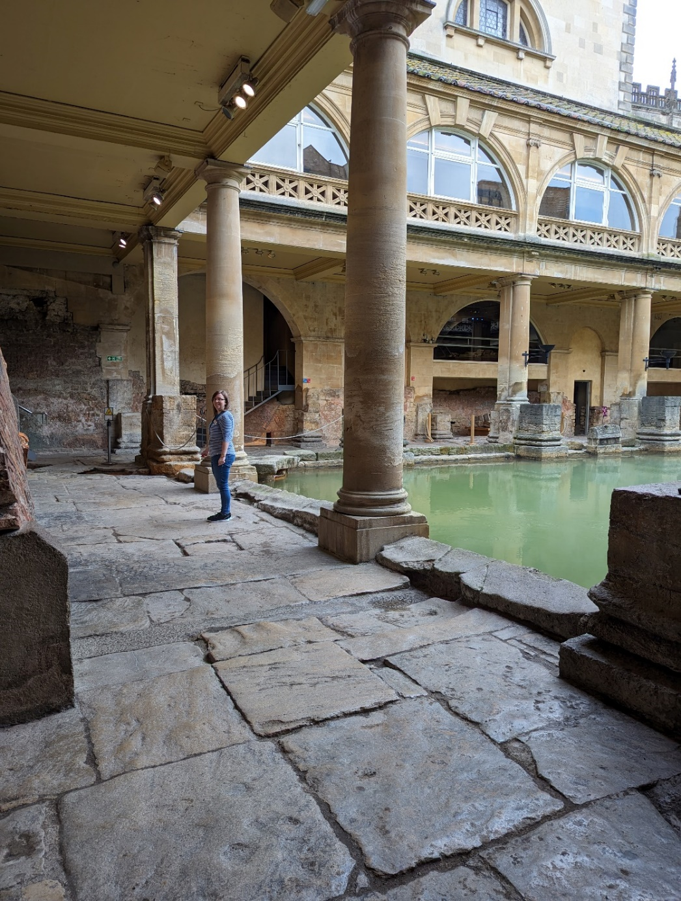

Please do not touch the water as it is very dirty.

This is the courier steps that we will walk up to go inside the museum.

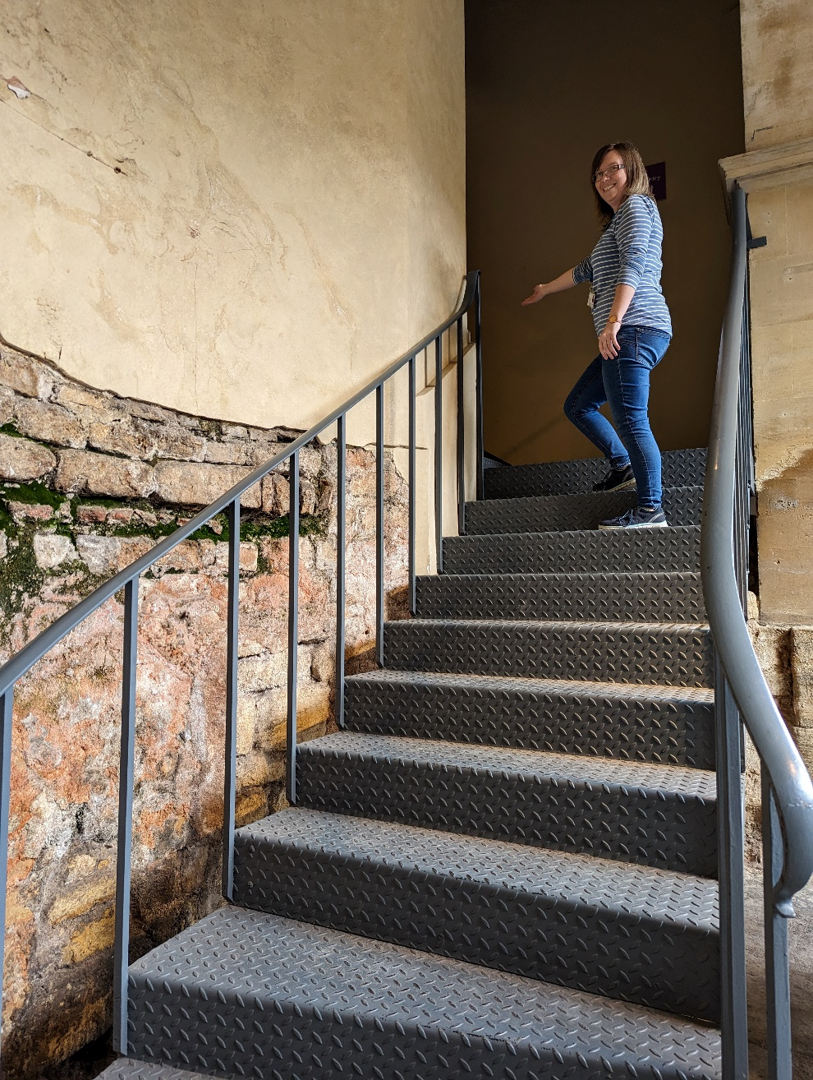

There are handrails to help guide you on the stairs.

We will use this door to enter the museum and turn left.
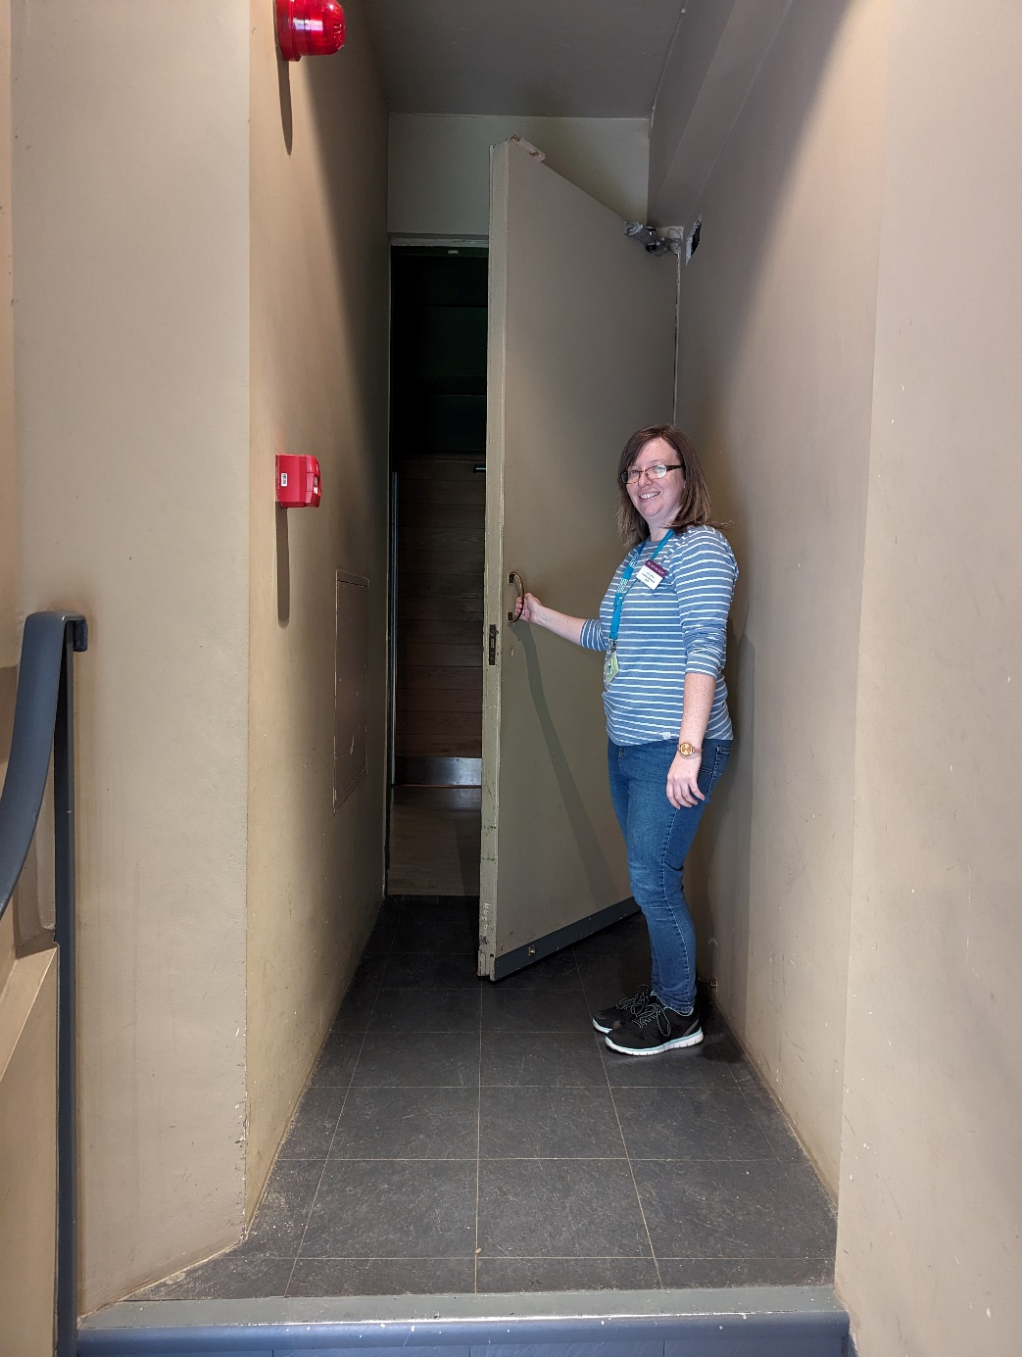

The museum will be slightly darker inside. We may need to wait for the stairs to be clear.
These are the stairs to go up to the Inner Terrace.
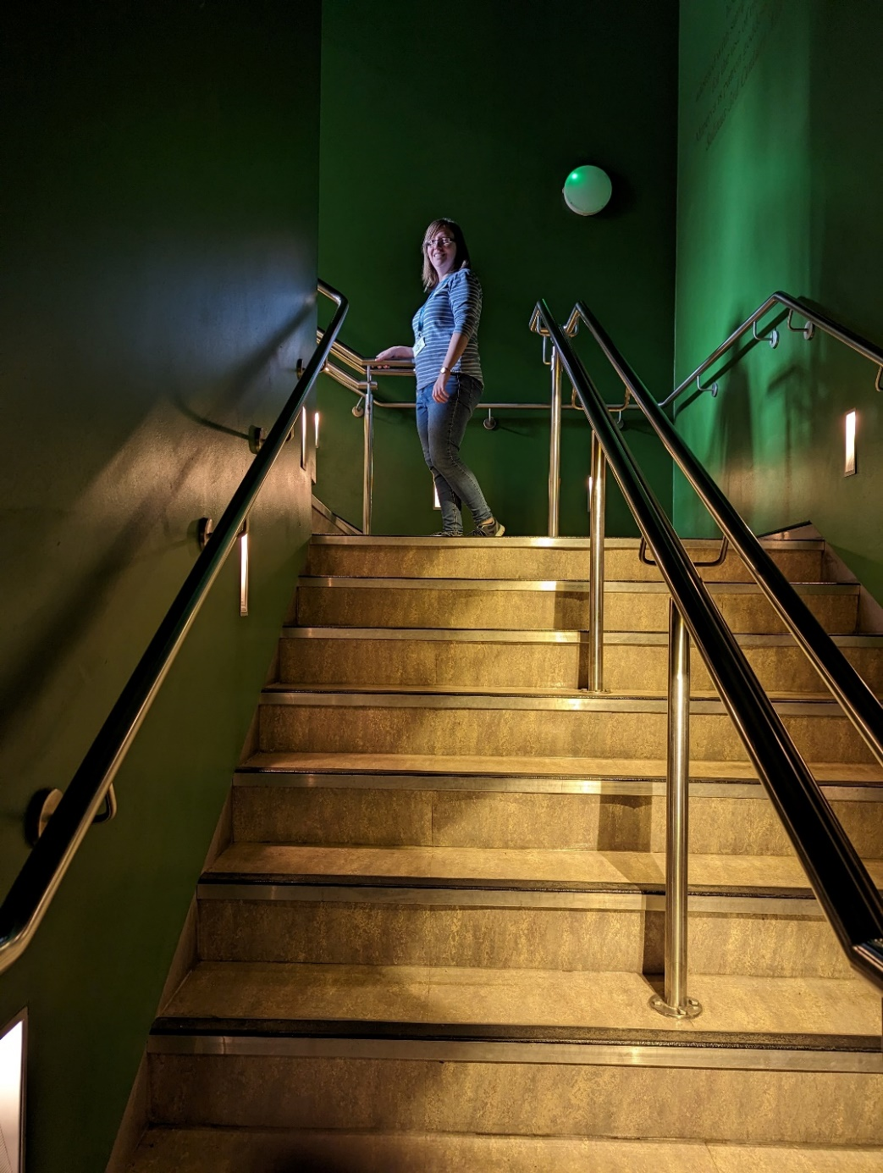

There are handrails to help guide you on the stairs.

This is the Inner Terrace where you will start your visit.
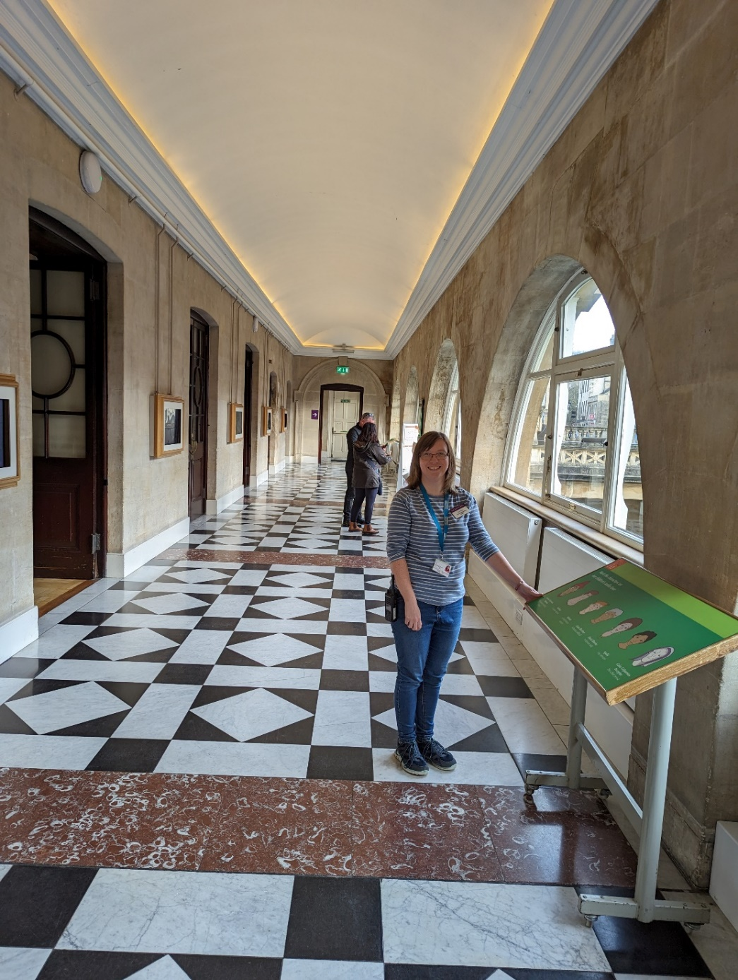

If you have an Audio Guide a member of staff will show you the first number.

The museum is self-guided. You can access The Roman Baths visual story through the website.

The Roman Baths Accessibility page

Or download a PDF

The Roman Baths Visual Story

Please let a member of staff know if you require assistance with accessibility.

When you are ready to return to The Clore Learning Centre please make you way to the Gymnasium.
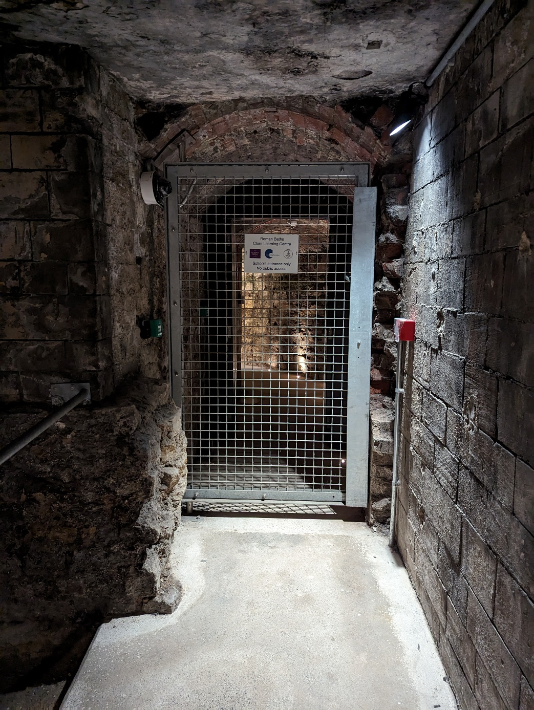

The gate will be shut. There will be a panel on the left for pass access.
An adult will use a pass to open the gate. They will need to hold it until the panel turns green.
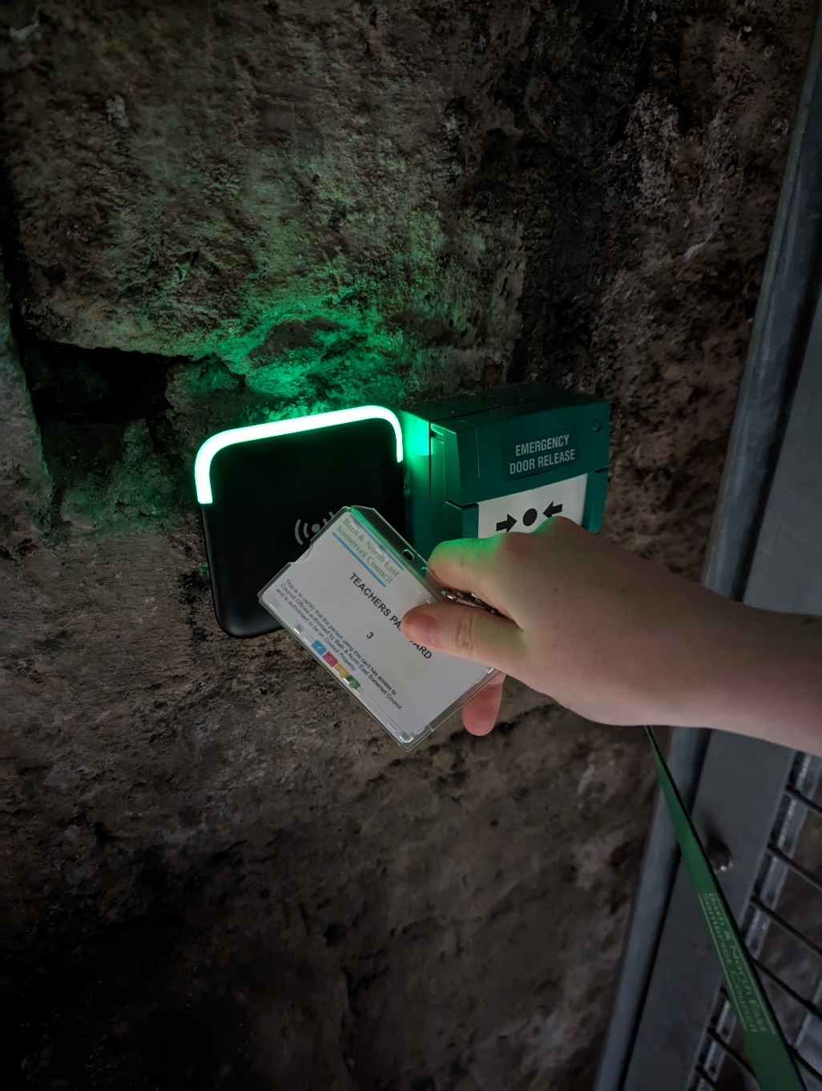

Please make sure an adult is at the back to close the gate behind the group.
When it is the end of your day, please collect your belongings. A staff member will guide you out.
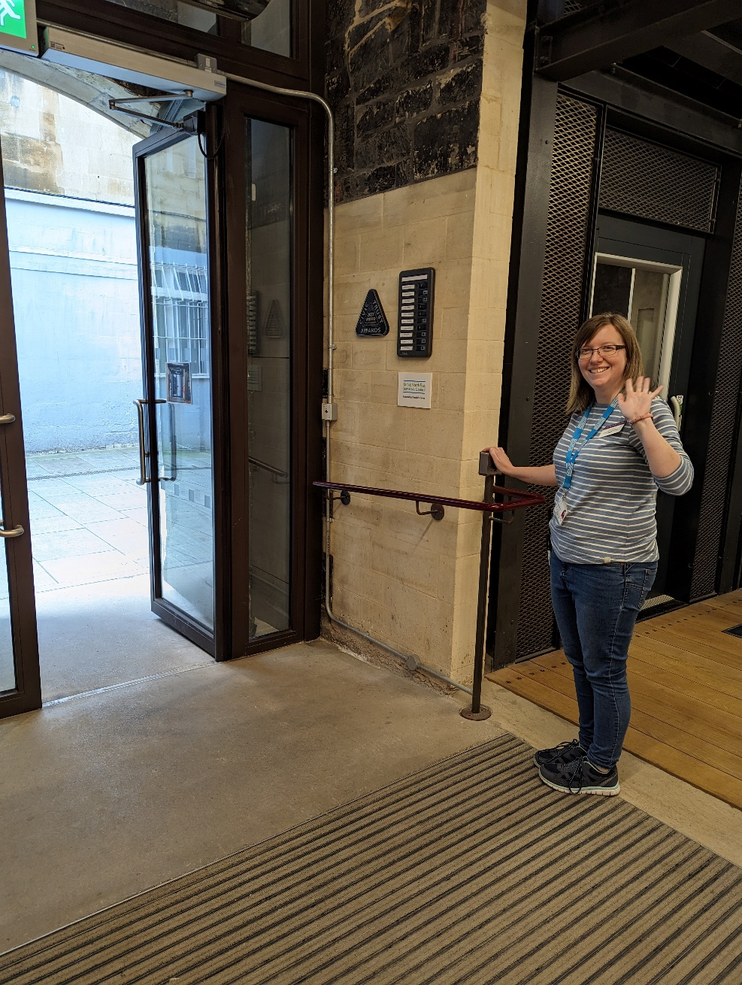

We hope you enjoy you visit to at The Clore learning Centre and The Roman Baths

