School/College
Address
Telephone
Main Contact |  | Email
Local Education Authority |  | % Free School Meals
Payment Contact |  | Email
Payment Options, please indicate which payment option you would prefer;
(1) to be made by card in advance of the visit – 01225 477785 (refunds will be provided)
(2) by card on the day by telephone – 01225 477785
(3) invoice after visit, please complete New Debtors Form and return to us along with completed booking form.

Number of students | Age | School year | Total number of adults | First Aider | Lunchroom required
 |  |  |  | Yes/No | Yes/No
Please advise us of any specific requirements – special needs, first language, wheelchair user etc.
Please note: For any child requiring 1:1 carer, the child would be charged standard entry and the carer is FOC

TEACHING SESSION DETAILS (max 35 people including teachers)
Please ensure you have at least 2 adults in each teaching session to keep the children on task and to manage the group effectively. Teaching Sessions held in Roman Baths Clore Learning Centre, entrance Swallow Street

Key Stages | For session info see: romanbaths.co.uk/schools | to select
EYFS Preschool/Reception age 3-5 | Brilliant Bladud – Bladud’s pigs and Roman artifacts
KS1/KS2 (90 mins) age 7-11 | Unearthing Aquae Sulis – Life in a Roman Town
KS3 (60 mins) age 11-14 | Interpreting Aquae Sulis – Evidence of Roman Daily Life
KS3/4 (60 mins) age 11-16 | Understanding Aquae Sulis – Bathing & Belief in a Roman Town
KS4 (60 mins) age 11-16 | 2,000 years of medicine – Romans to the present day
KS4/5 (60 mins) age 16 plus | Bathing & Beauty
KS4/5 age 16 plus | Branding the Roman Baths
International Students (60 mins) | Getting a Job in a Museum

First choice of date |  | Teaching session time(s) |  | Arrival time
Second choice of date |  | Teaching session time(s) |  | Departure time

PLEASE RETURN THIS FORM TO: romanbaths_bookings@bathnes.gov.uk

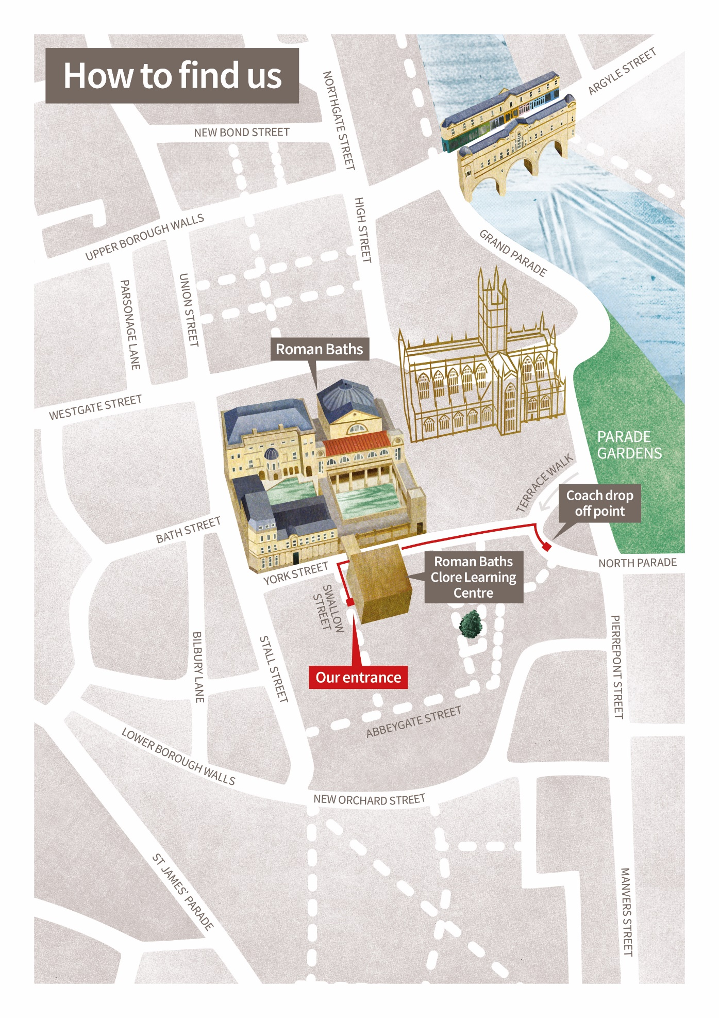

Facilitated School Groups Terms and Conditions 2024 - 2025

1 | We are operating a new access fund scheme to enable all schools to have a high quality, immersive experience.  Eligibility criteria applies. Schools must be state funded primary, secondary or special school or unit and have 30% or more of children in receipt of free school meals (FSM). The fund covers the cost for general admission as well as a facilitated teaching session.  We do not require proof of 30% on booking but we will be doing spot checks and schools must be able to demonstrate they meet the criteria. We will issue an invoice if the eligibility criteria is not met.
2 | Admission will only be permitted on production of your email confirmation; on presentation of this our staff will supply you with the correct number of tickets.  The email confirmation will be emailed to the email registered on our system. Please ensure that this is emailed to the group leader ahead of their arrival at the Roman Baths.
3 | We only invoice schools who have arranged to be invoiced in advance of their visit. Other schools must settle their balance in advance of the visit date. As the person making the booking it is your responsibility to ensure that your finance team receive the invoice and that it is paid on time. In the unlikely event that your invoice is not paid by your payment due date, you will be chased for payment by our finance team.  All outstanding invoices must be settled before any further bookings will be made. For schools booking in July your invoice will be sent in August and you must ensure that this is paid on receipt. Payment by debit/cred card in advance is available should your office be closed over the summer.
4 | Payment must be made for the full invoice amount. If you have a query regarding your invoice you must contact our customer service team as soon as possible by emailing romanbaths_bookings@bathnes.gov.uk or call 01225 477785.
5 | Admission charges are based on those existing at time of the visit. Child rates are applicable to children between 6 years and 18 years inclusive during term time and Monday to Friday.
6 | Teachers accompanying educational groups of 20 or more are admitted free on condition that they supervise their group throughout the visit according to the following ratio:  Up to 11 years: 1 free per 10 children  12 years upwards: 1 free per 15 children
7 | Disabled visitors pay the normal price for admission, the accompanying carer goes free. Carers will need to be declared and added when making the booking and cannot be added on arrival. Please advise us at the time of booking if any of your party require wheelchair access.
8 | We expect teachers to create a visit risk assessment and to ensure the right number of adults. Please inform us of changes to group numbers ahead of the visit.
9 | We expect teachers to assist with the visit at all times and to be in charge of pupil behaviour. To be in charge of the group throughout the museum and to work with the session leader to keep children focused on the learning task.
10 | Due to the number of sessions that we deliver during the day please be aware that if your group is late, you may receive a shortened session. We will work with the group leader to rearrange the timings.
11 | General visitor Terms and Conditions and code of Conduct also apply to your group please make yourself and your group leaders aware of these here:  https//www.romanbaths.co.uk/terms

